# Multi-Projector geometric Warping and Blending with X-Plane on the NVIDIA GPU

By Reto Stöckli, 2 December 2024

#### Introduction

This is about setting up multi-projector visuals on a cylindrical screen for a flight simulator home cockpit. There are three image transformations one will need to accomplish for it to work properly.

1. Transformation of the rendered content from a flat to a cylindrical projection
2. Warping of the projected image to the cylindrical screen geometry
3. Blending of the individual projected images at their overlapping regions

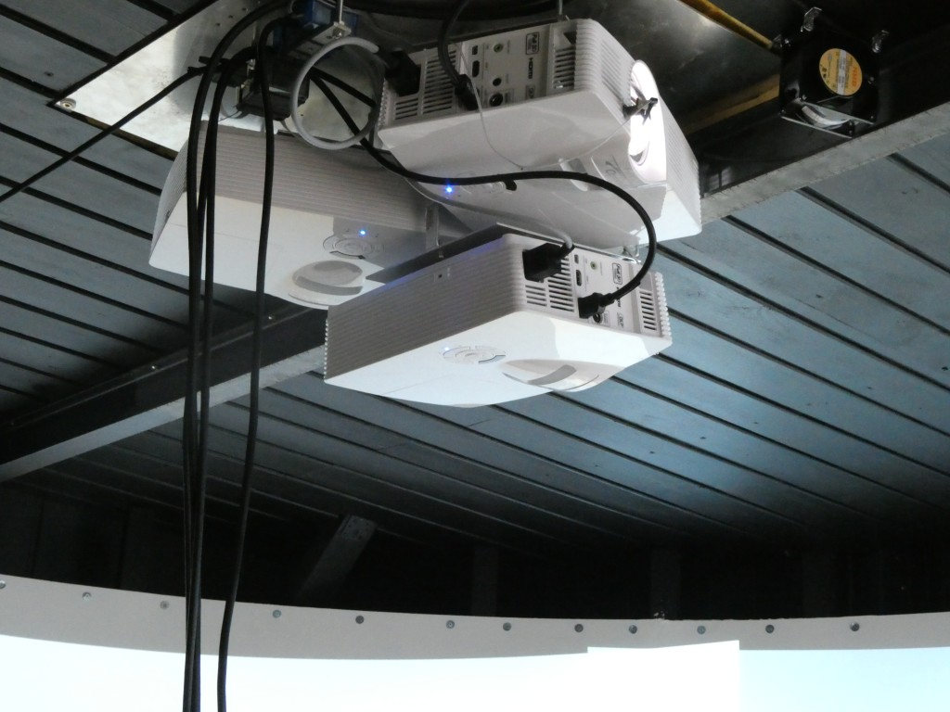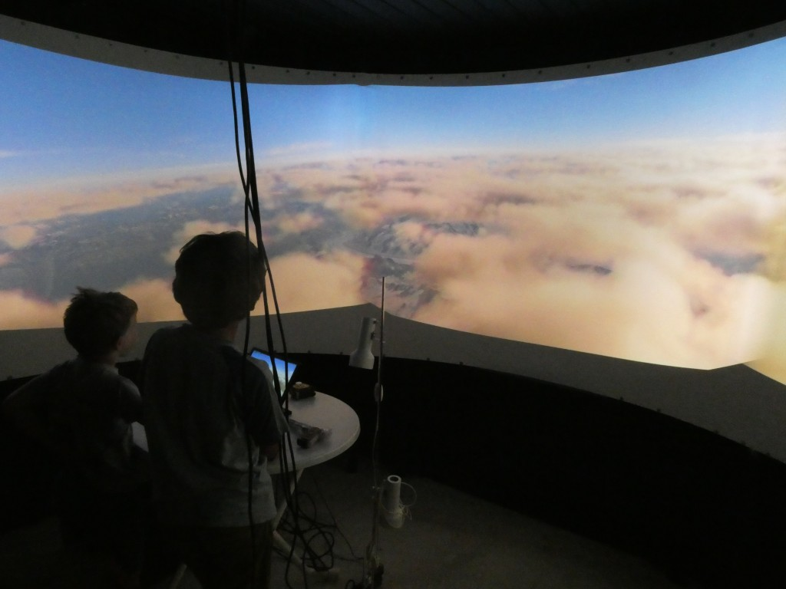

Figure 1: Sample projector system (left) with fully operational warp & blend software on the cylindrical screen (right) in my setup. Center projector is tilted to cover the same vertical area as the other two since it has a lower mount.

There are several software solutions to achieve these three steps. These are for instance, among others, [Fly Elise NG](https://fly.elise-ng.net/), [Warpalizer](https://www.warpalizer.com/) or [Pixelwix](https://www.pixelwix.com/). Their price ranges from a few hundred to a few thousand US$, which is justified for the amount of sophisticated projection design, calibration and transformation features offered. Most of the software packages include manual, geometric and camera-based warping technology and are suitable driving a highly complex and professional multi-projector setup for commercial use. However, if you’re a home cockpit builder like I am, these solutions are too sophisticated. They further make you dependent on yet another third party supplier, which can cause sleepless nights in case of missing updates and incompatibilities. And if you work on Linux like I am, these solutions do not apply at all since they all require Windows.

There is a simple solution to that: if you use [X-Plane](https://www.x-plane.com/), it has steps 1 — 3 built in. No need to buy an additional software: planar – cylindrical transformation, warping to cylindrical screen and blending **IS** part of X-Plane. Thanks to Austin and his superb crew!

However, there are three drawbacks in X-Plane’s native support for multi-projector setups:

1. Transformation from planar to cylindrical projection cuts of a substantial part of the image at image edges.
2. You can only manually define the warping grid, which needs quite some fiddling with many control points and a horizontal / vertical laser calibration.
3. You have to buy the PRO Version of X-Plane for around 1000 US$. This is fine for commercial users charging 100-200 US$ per hour of flight. I however build the flight simulator for my own pleasure, but still would like to run it in a highly realistic environment with multiple projectors and a curved screen.

I am now going to show how to implement steps 1 — 3 and concurrently curing X-Plane shortcomings A — C, all native on Linux and free of cost. AND: to stay 100% compatible with X-Plane’s native warping and blending. All related code is available open source on github.

#### Transforming Rendered Content from Planar to Cylindrical Projection

The 3D content of computer games is rendered on an imaginary flat plane sitting in front of the user. Ideally this plane reflects the distance of the flat monitor from the user. This means that the horizontal and vertical Field Of Views (FOVx and FOVy) of the rendered plane and of the eye-to-monitor geometry are comparable. To cover a true 180 degree FOVx the monitor would need to be infinitely wide. This trouble can be avoided by having a cylindrical screen around you. However, it requires to reproject the image content of the planar rendering in your application into a cylindrical projection. So, if you ever buy a curved monitor and think that your game will look nicer, you simply got fooled. The content at the edges will simply appear closer than it really is and you might get a headache from playing. Those curved monitors would need a game that can render its content on a curved monitor. Which is not the case for any of the games I know. Except for [X-Plane](https://www.x-plane.com/). And the latter is said not to be a game.

The solution to render on curved or cylindrical (or even spherical) screens is very simple and applied in most panorama stitching software: it is a simple geometric transformation from X / Y to horizontal angle and screen height coordinates:

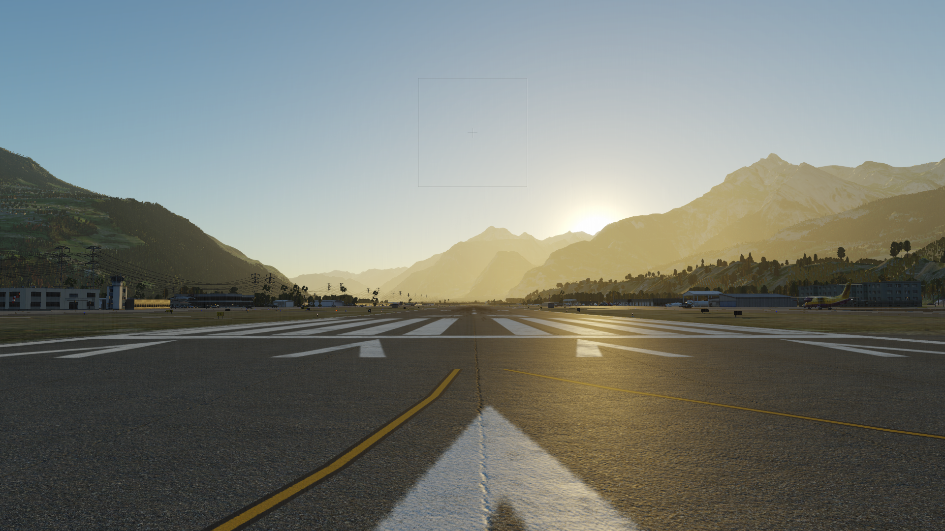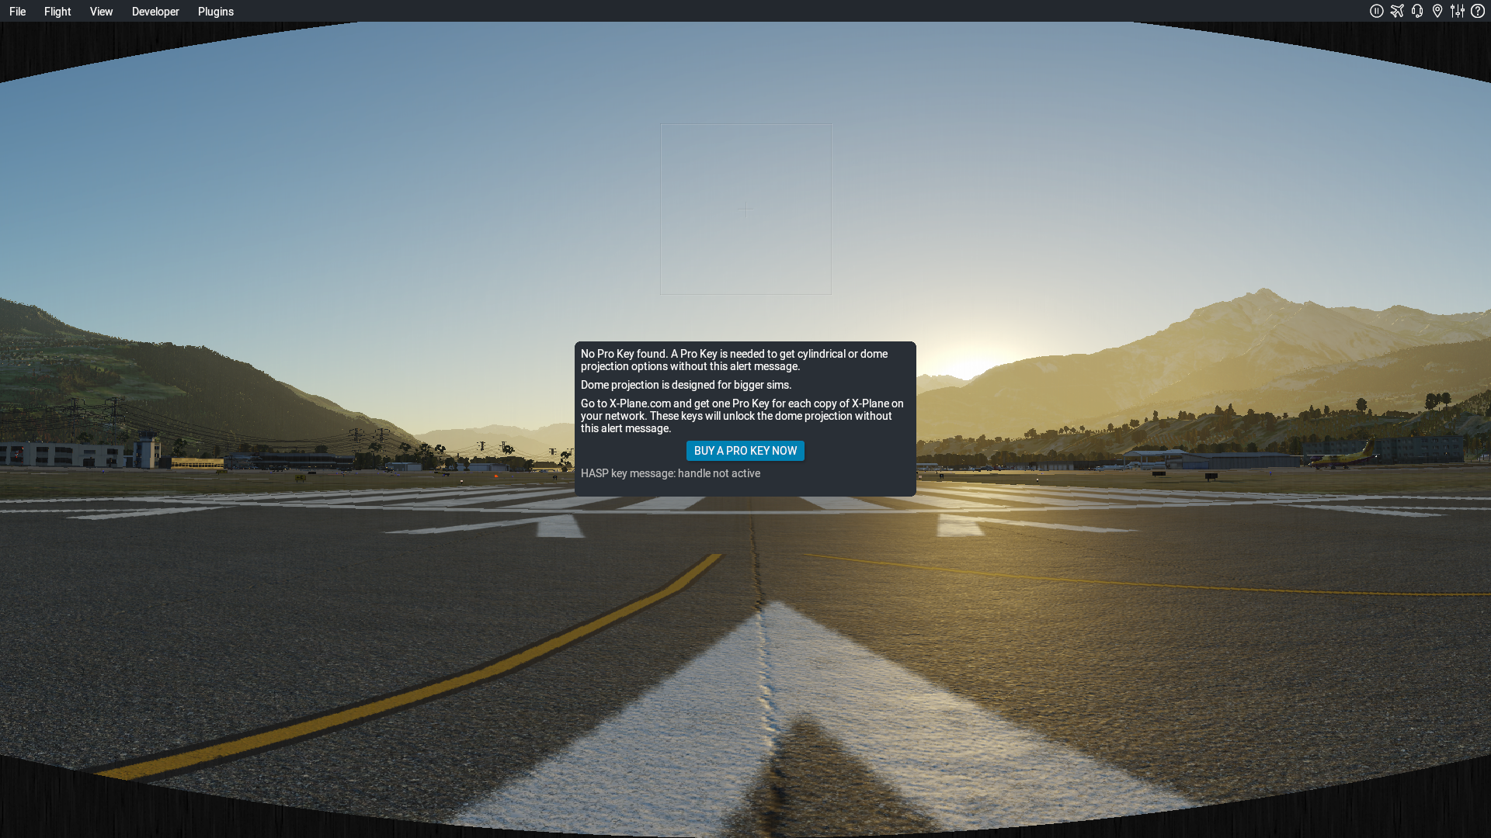

Figure 2: Planar rendering (left) and cylindrical transformation (right) of the planar rendering. Note about the dialog box in the right image: in order to use the advanced projection features without the warning box the [professional version of X-Plane](https://www.x-plane.com/pro/) has to be bought. I don’t have it. The images here are just displayed for demonstration purpose and thus contain the warning dialog box.

One cannot stitch planar rendered images at their edges. A transformation is needed to a cylinder projection prior to stitching. The images below show stitches of two adjacent views at their overlap area. The left stitch uses two planar rendered images. Features don’t match at high view angles (check out the mountains). The right stitch uses two cylindrical renderings and allows perfect stitching of the same overlapping scene.

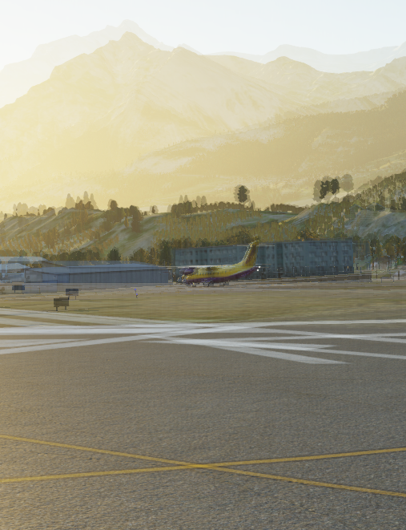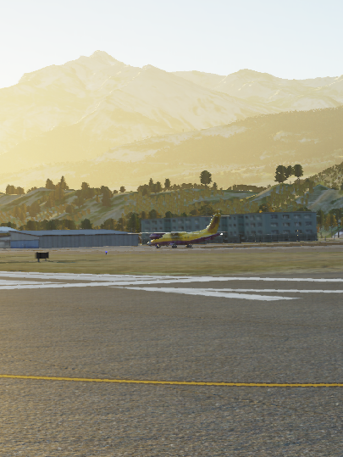

Figure 3: Stitching the planar rendered (left) and the cylinder transformed (right) image.

The cylinder projection is a basic geometric projection used in geographic mapping or in photography. An overview of the formulas can be found here: <https://cs.brown.edu/courses/cs129/results/final/yunmiao/>

<https://mathworld.wolfram.com/CylindricalProjection.html>

The code implemented can be found in my Python routine here <https://github.com/retostockli/xpcockpit/blob/master/warpblend/scripts/warpmatrix.py>

A common cylindrical projection squeezes the scenery vertically. In the X-Plane internal solution this is overcome by linearly stretching it during the planar to cylindrical projection. This still leaves unused (black) screen areas at the corners due to the planar to cylindrical projection geometry. My solution in the above code is to render a slightly higher FOVy and stretch the vertical coordinates so that the reprojected rendered content entirely fills the image. Additional stretching has to be proportional to the tan() of the additional FOVy. This will in turn render unused / unseen content in the upper and lower center of the projected area but fill the corners.

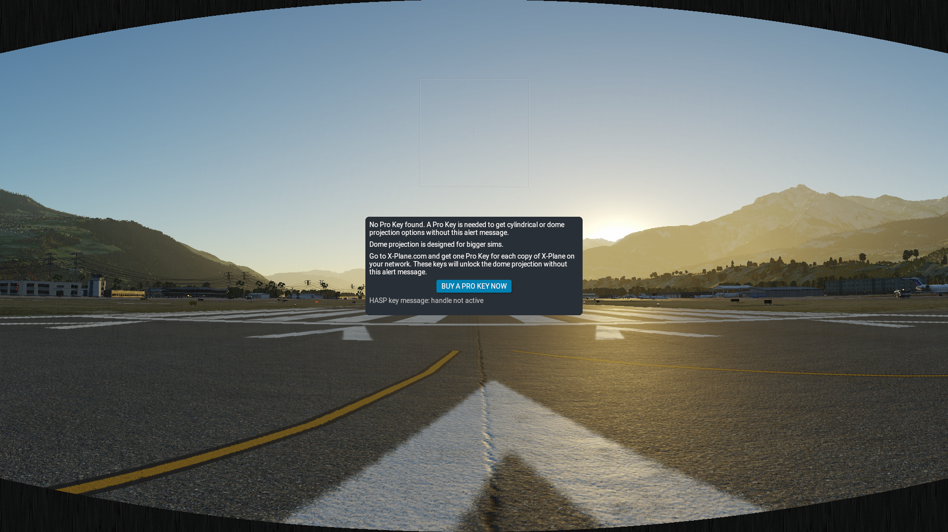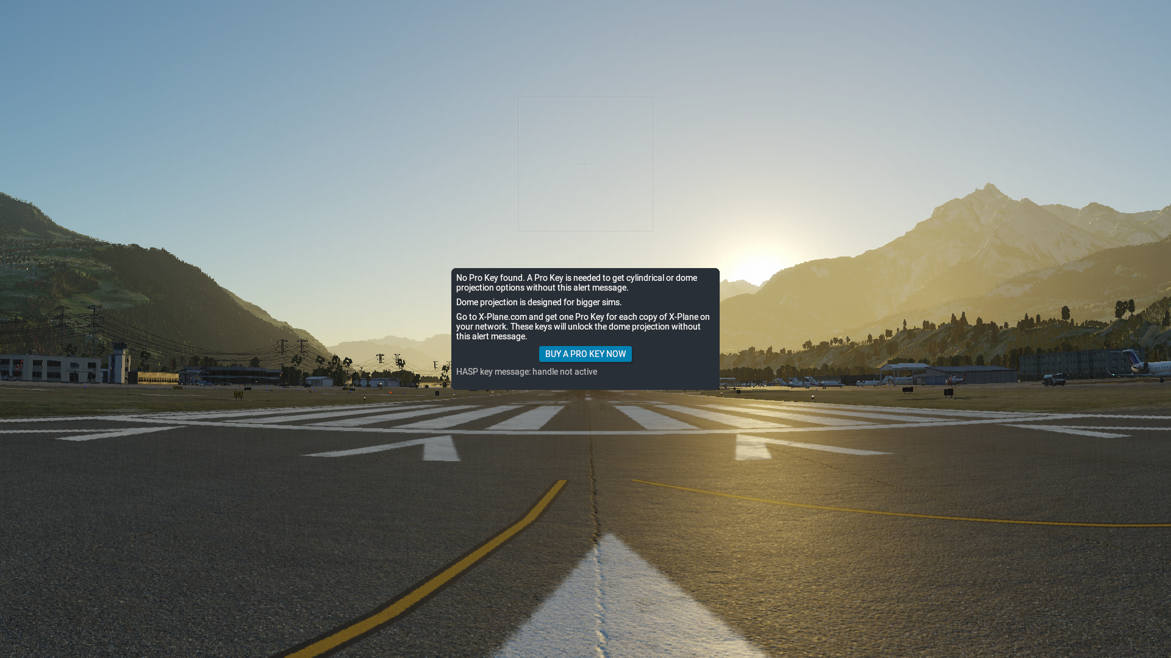

Figure 4: X-Plane’s native cylinder projection (left) and image filling cylinder projection using a higher FOVy and vertical stretch (right).

Rendering a higher FOVy might produce a higher CPU and GPU load since more objects will need to be calculated. In my setup with a per-projector FOVx of 77.6º, the FOVx has to be increased from 48.6º to 52.1º, which is acceptable. This solves puzzle A as defined above.

### 2. Warping and Blending of the projected image to the cylindrical screen geometry

Now here we get to the complicated part. Projectors are built to display on a flat / planar screen mounted orthogonal in front of the projector axis.

* If the projector is tilted, the so-called “keystone” effect has to be corrected. The image appears wider on the upper than on the lower border (or vice versa) and the image is squeezed vertically.
* If you project on a cylindrical screen, pixels in the center of each projector image travel farther than they are intended on a planar screen. The image in the center becomes vertically exaggerated.

The classic way to overcome this is to set up a grid of control points and manually make these points level again with the help of a laser leveler. The laser leveler can be found in every hardware shop and will draw precise horizontal and vertical lines on your cylindrical screen. You can use it to mark a “real’ grid on you cylindrical screen, then adjust your warping grid points to this “real” grid. Let us call this the empirical warping method. This method is available in X-Plane and in most projection software solutions.

Most projection software solutions also include a camera-based warping method. A simple web cam connected to the projection software and filming the projection screen allows to adjust the warping grid automatically. This solution is usually free of trouble, but you have to buy it.

The solution that I propose here is the so-called geometric warping. It is available in some projection software solutions as well. You most likely know the size and radius of your projection screen and you know the distances and tilt angles of your projectors.

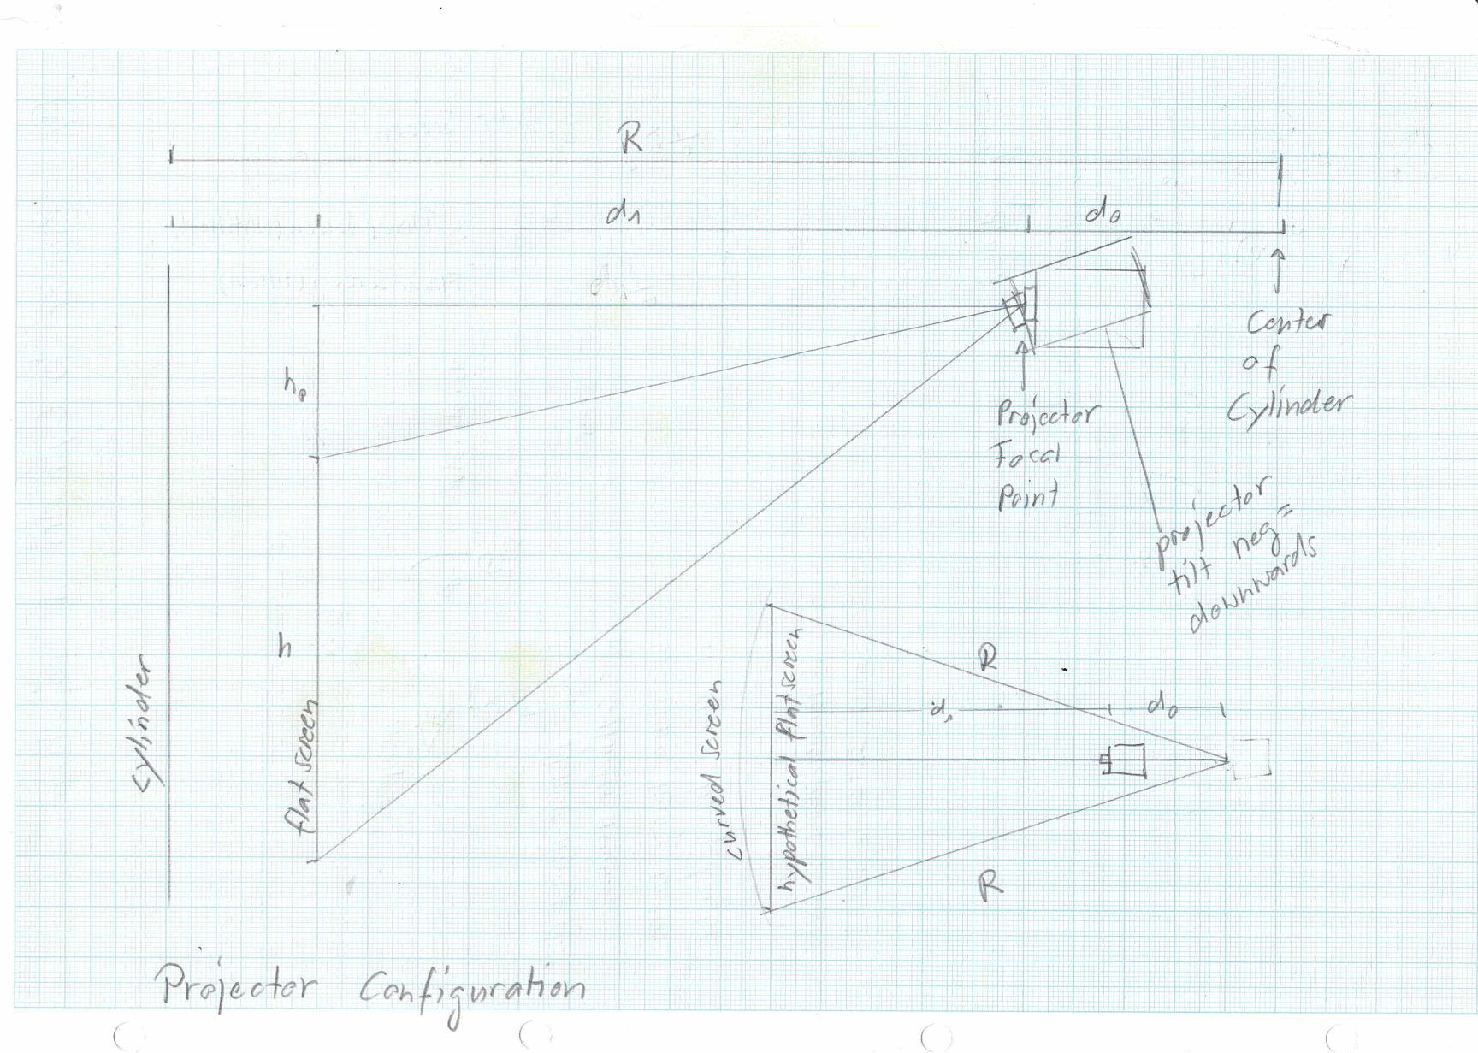

Figure 5: Basic projector and screen distances and angles

This is good news, since with the application of a few trigonometric functions one can calculate the position of each projected pixel on the cylindrical screen and in turn also correct this position for its displacement due to the rounded nature of the screen. The solution is very simple for projectors mounted radially from the center of the projector screen and pointing in the direction of the screen. I have implemented exactly this in my python code (linked above).

Please familiarize yourself with the sketch of the projection geometry in Figure 8. We project a pixel from the projector located at x1,y1,0 onto the cylindrical screen at xc,yc,zc. The resulting pixel location on the curved screen is too high since we overshoot the hypothetical planar projection plane and land on the curved screen behind at a higher elevation. We now have to calculate how far we have to shift the pixel downwards to again match the height ze at the hypothetical planar screen. The calculation is a bit more strenuous for a tilted projector, but still does not exceed basic geometry stuff we had learned in college many years back.

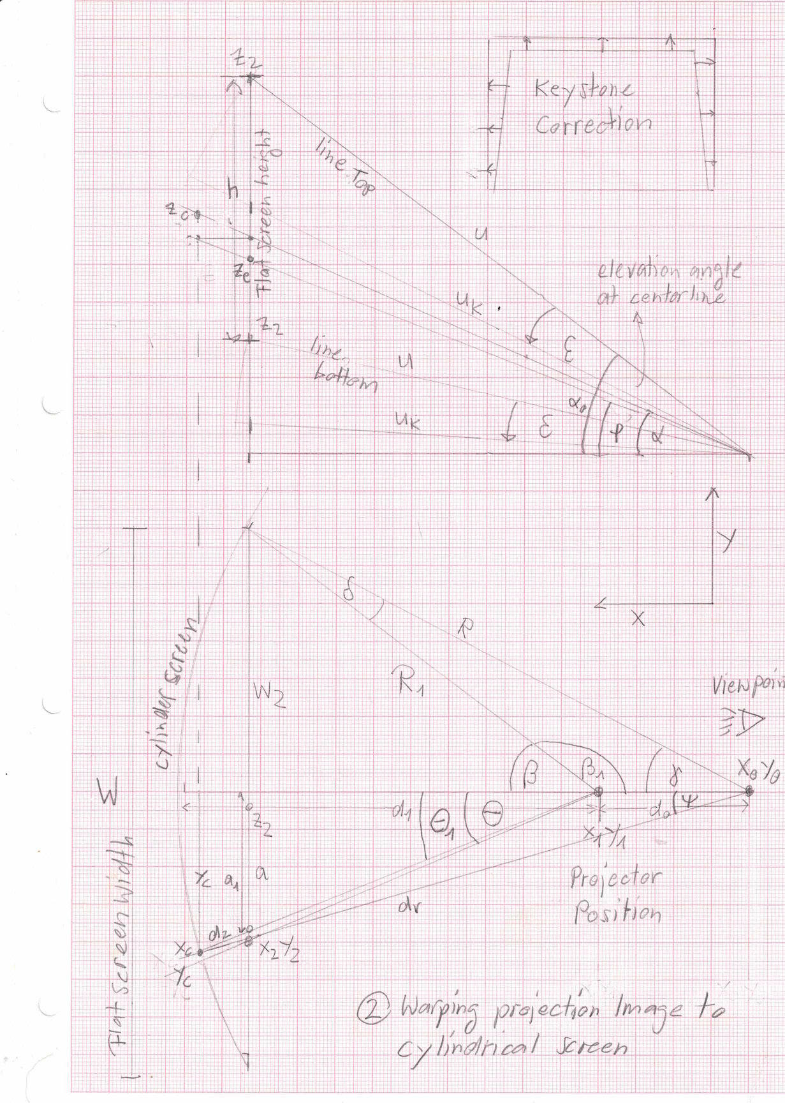

Figure 6: Schematic of the projection – screen geometry. Vertical (top) and horizontal view (bottom).

It gets a bit more complicated if the projector is tilted up or down (see tilt angles epsilon in above Schematic). But this is perfectly solvable. Note that I have not implemented the solution for projectors which are not mounted radially and / or pointing away from the radial direction to the screen.

What parameters are needed to apply a geometric warping solution:

* Radius of screen R [cm]
* Throw ratio of projector tr [-]
* Distance of projector focal point (or lens front, if not known) from center of screen d0 [cm]
* Lower height h0 of image above focal point (or lens center if not known) when projected at a screen in distance d1 [cm]
* Projector tilt angle ε [deg]

The code to calculate the projection geometry and the resulting warping grid is written in python and called warpblend.py (find it [here on github](https://github.com/retostockli/xpcockpit/blob/master/warpblend/scripts/warpmatrix.py)).

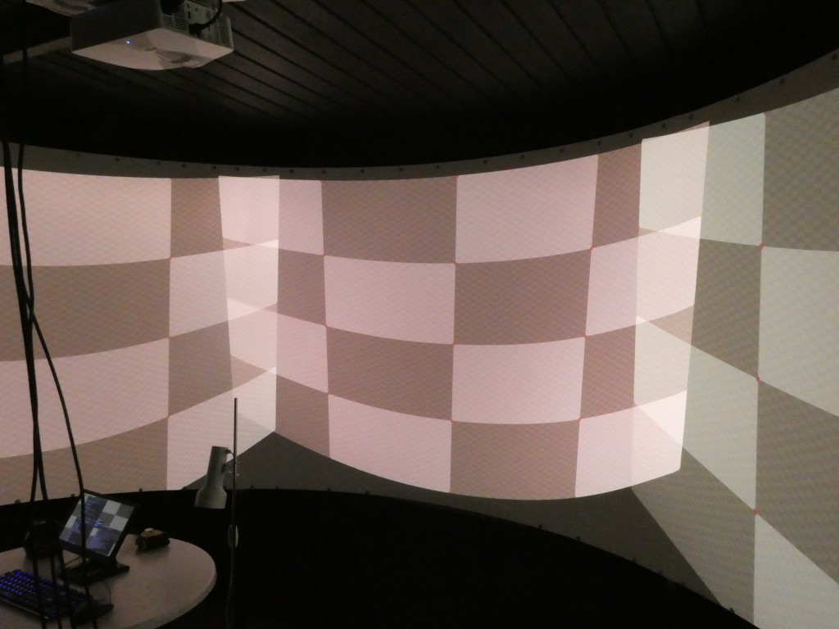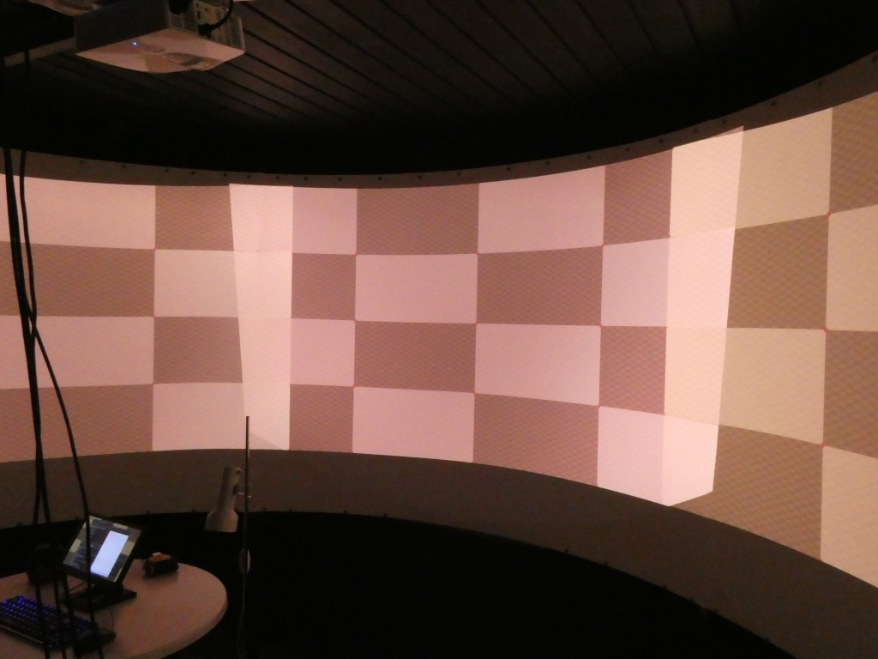

Figure 7: Unwarped (left) and warped (right) projection grid on a cylindrical screen.

That right image displays a perfectly aligned warping grid without any manual adjustments of the warping points. This grid was entirely calculated from knowing the projector location and parameters and the screen location and radius. It’s geometry, stupid!

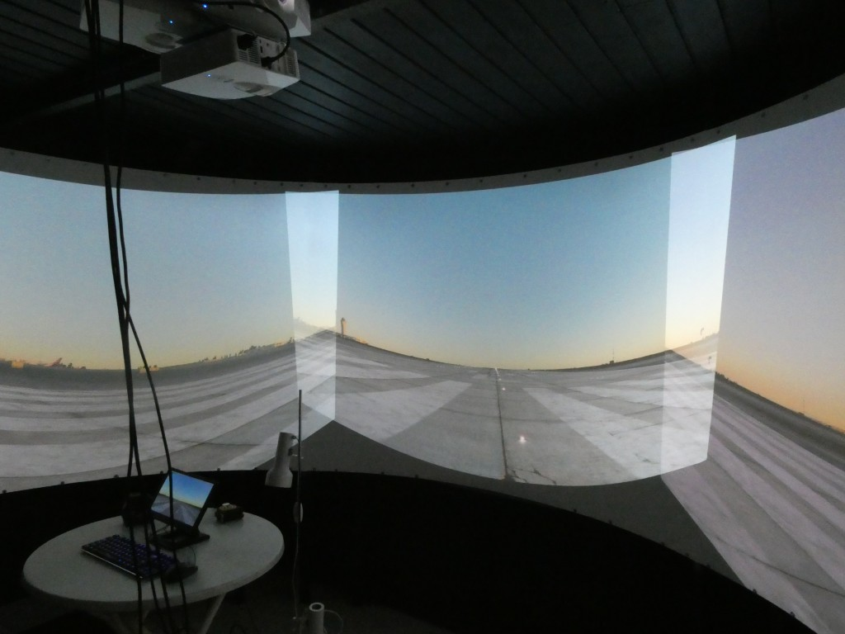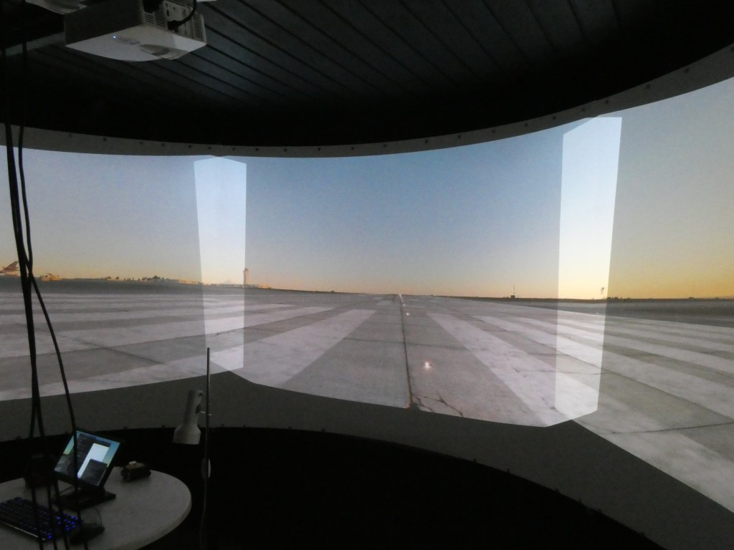

Figure 8: Unwarped X-Plane output on a cylindrical screen (left) and warped geometry on a cylindrical screen (right). Please note that these images are not yet blended at the overlaps.

The resulting warping grid could still be manually adjusted since neither the projector lens nor the cylindrical screen are perfect. In the Figure below a few differences between the horizontal laser line and the warping grid can be identified. In practice these differences will not be visible in the real image.

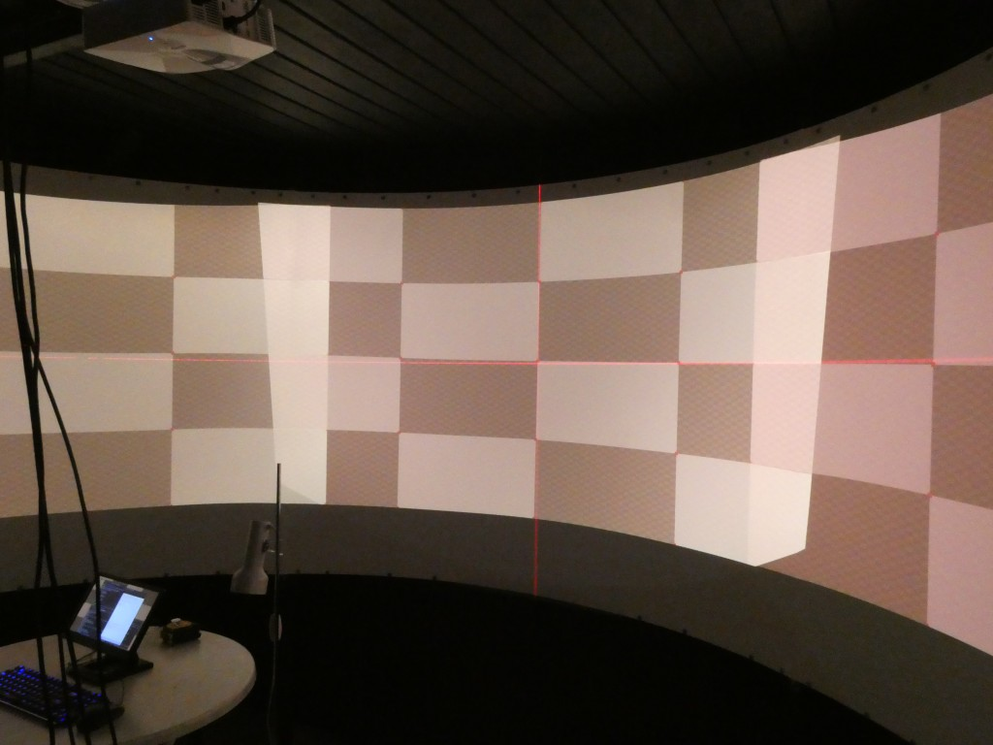

Figure 9: The geometrically calculated warping grid tested with a horizontally leveled laser pointer.

* The python Code warpblend.py generates a warping grid which is written into a regular ‘X-Plane Window Positions.prf’ preference file.
* This file goes into the directory ‘Output/preferences’ of X-Plane.
* Planar to cylindrical image projection (see step 1) is also stored in the warping grid. This is different to X-Plane where only the geometric projection warping is stored into the warping grid.
* If you use the warping grid of my code, simply leave the ‘use cylindrical projection on all displays’ in X-Plane’s projection dialog box unticked.

3. Blending of the individual projected images at their overlapping regions

Well, blending is not a big science. One has to control the alpha level of the projected image through the overlapping regions. It is wise to choose a non linear alpha level curve as RGB intensity values are not linearly transformed into light intensity in the projector. The so-called gamma level of projecting devices may vary. A blend curve using an exponent of 1/2 to 3/4 resulted in best results.

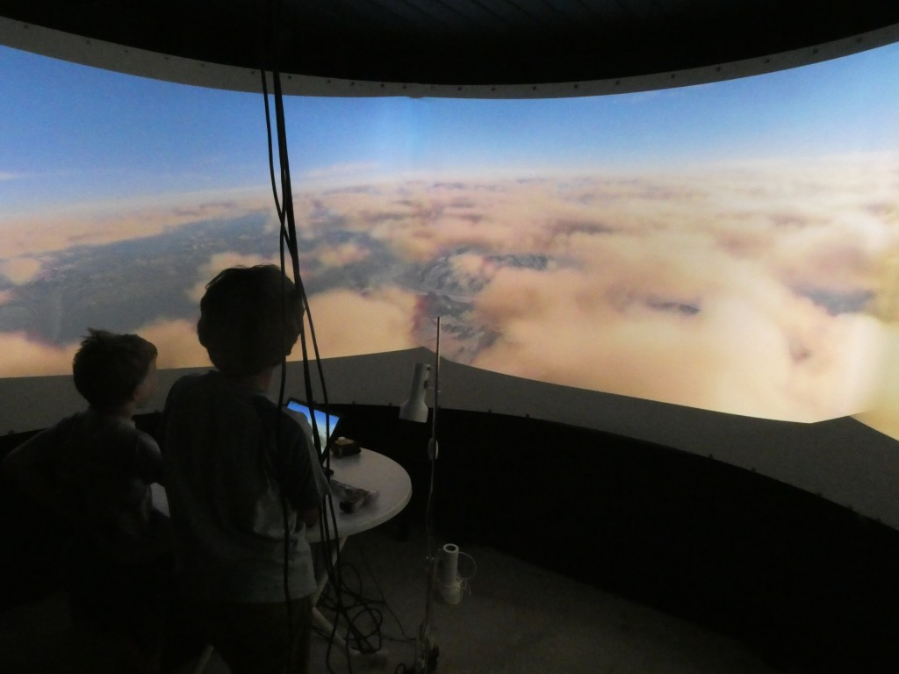

Figure 10: Warped and blended X-Plane Output on a cylindrical screen.

For Windows users: you can use everything up to this step. Same file, same warping grid.

Blending information calculated in warpblend.py is also stored in the file ‘X-Plane Window Positions.prf’.

### Summary

You have learned that a perfect projection warping to a cylindrical screen can be achieved without even moving a single control point by hand. Given you know the dimensions of the screen and some specifications of your projector, it can be done by use of a (relatively simple) python script to calculate corrected pixel positions for your projector. For this calculation projectors have to be arranged radially towards the screen, but they can be tilted. In case they would be positioned anywhere on your ceiling, the geometric correction presented here would need to be adapted.

### Speeding things up by running it natively on the NVIDIA GPU

When loading the warping grid in X-Plane and applying blending on three screens you will notice some increase in CPU load which might lead to a drop in frame rate when running the flight simulator. Also, running a warp & blend in X-Plane requires you to buy the professional version of X-Plane. This is adequate for companies training real pilots or earning money from public tours, but not for hobby sim builders.

Fortunately, NVIDIA has built a native support for image warping and blending. And the good news is that these features come at almost no cost, neither for GPU nor for CPU. So, what I am going to demonstrate here for Linux is how to read the X-Plane’s warping grid and blending directly into your NVIDIA card and run it from there. This saves X-Plane from doing these calculations, so X-Plane can concentrate on flight dynamics and scenery.

The theory and API behind this functionality is explained very well in a presentation Doug Traill held at the GTC 2017 conference (Presentation not currently found on the internet, but more information is available here: <https://developer.nvidia.com/warp-and-blend> ). The API is implemented for both Windows and Linux. Since I have no access to a Windows programming environment the whole work has been done on Linux by using the sample code nv-control-warpblend.c found in nvidia-settings (<https://github.com/NVIDIA/nvidia-settings> ). It should be pretty simple for a programmer to add the windows functionality with the Windows API of NVIDIA.

My code does the following: it reads the regular ‘X-Plane Window Positions.prf’ file and fills the NVIDIA warp matrix polygons with it. It also reads the blend information out of this file and creates the projector edge blending natively on the NVIDIA GPU.

There is no magic about it, I am just using what is already available. My code can be found here:

<https://github.com/retostockli/xpcockpit/tree/master/warpblend/src>